Project Design Phase-II Technology Stack (Architecture & Stack)

|  |  |
| --- | --- |
| Date | 17October 2022 |
| Team ID | PNT2022TMID13705 |
| Project Name | Gas Leakage Monitoring and Alerting System for  Industries |
| Maximum Marks | 4 Marks |

Technical architecture:

Figure: Gas Leakage Monitoring and Alerting System

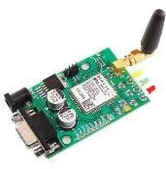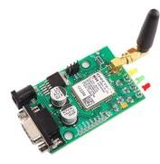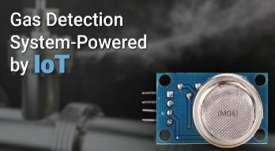

IOT DEVICES

**user**

**Cloud Service**

Cloud DB

IBM Watson IOT Platform

GSM Module

Table-1 : Components & Technologies:

|  |  |  |  |
| --- | --- | --- | --- |
| **S.No** | **Component** | **Description** | **Technology** |
| 1. | User Interface | User has to register and we can  able to view the other device. ex: using web UI, mobile app etc., | HTML, CSS, JavaScript |
| 2. | IOT Application Logic-1 | Owner’s device should be connected to the system | Python |
| 3. | IOT Application Logic-2 | Owner’s device should be in on condition | IBM Watson STT service |
| 4. | IOT Application Logic-3 | If gas leakage is detected the notification message is send to the owner | IBM Watson Assistant |
| 5. | Database | Data type can be any form such as  text, User defined blob of data sent from cloud IOT core device etc., | SQ lite, In Flux DB |
| 6. | File Storage | File with be labelled with what they contain and how long they should  be kept | IBM Block Storage or Local File system |
| 7. | External API-1 | Purpose of External API used in the device is to use the internet for communicating and conducting  allotted operations efficiency. | Aadhar API, etc. |
| 8. | Machine Learning Model | IOT and machine learning delivers insights otherwise hidden in data for rapid automated response and  improved decision making | Object Recognition Model, Danger prediction Model etc. |

Table-2: Application Characteristics:

|  |  |  |  |
| --- | --- | --- | --- |
| **S.No** | **Characteristics** | **Description** | **Technology** |
| 1. | Open-Source Frameworks | Device that removes much of the manual work needed to write and configure code. It provides rapid development ,is easy to setup and has a strong  support base | IOT Zeta for nonstop streaming of detecting gas leakage level, |
| 2. | Security Implementations | Alert notification Enabled with GPS module received in owner mobile. | e.g. SHA-256, Encryptions of data regarding gas level, firewalls, Antivirus, data loss prevention etc., |
| 3. | Scalable Architecture | If a problem arises owner can see the problems and check gas level simultaneously | Multiple Data store Technologies , Reliable, Micro services Automated  Bootstrapping |
| 4. | Availability | *sensor to detect the  leakage and LCD Display to show gas level | GSM module, raspberry pi |

|  |  |  |  |
| --- | --- | --- | --- |
| **S.No** | **Characteristics** | **Description** | **Technology** |
|  |  | *whenever the gas leakage is sensed the message is  delivered to the owner |  |
| 5. | Performance | *the alert notification is sent to the owner without any delay when leakage is detected  *immediate actions are taken after detection. | High durable device battery |